|  |
| --- |
| Creating Web Application |
| COS10011  Semester 1, 2021 |
|  |
|  |
|  |

|  |  |
| --- | --- |
| Member Name | Member ID |
| Kelvin Ho Juin Ket | 101234677 |

|  |
| --- |
|  |

Table of Contents

Assignment 1 2

1. Introduction 2

1.1 Scope of the website 2

1.2 Intended audience 2

2. Webpage Design and Structure 3

2.1 Website Layout Mock ups 3

2.2 Website Structure 9

3. End Product 10

3.1 Actual User Interface 10

3.2 Enhancements (if any) 16

Assignment 2 17

1. Description 17

2. End Product 18

2.1 Enhancements 21

Assignment 3 23

1. Description 23

2. MySQL database structure/schema 28

3. End Product 29

3.1 Enhancements (if any) 32

# Assignment 1

## Introduction

### Scope of the website

This website is an informative website that provides users the information about Habor Resort which allocated at Kota Kinabalu, Sabah. The website also provides an enquiry page that users can easily enquire anything about the website or the resort.

### Intended audience

Tourist and native

## Webpage Design and Structure

### 2.1 Website Layout Mock ups

Logo

Navigation Menu

Image Slider

Location

Content

Figure 1: index.html

Footer

Logo

Navigation Menu

Footer

Product Image

Product Header

SubProduct1

SubProduct1 Image

SubProduct3

SubProduct3 Image

SubProduct2

SubProduct2 Image

SubProduct2

SubProduct2 Image

Figure 2: roombooking.html, facilities.html, food.html

Logo

Navigation Menu

Footer

Product Image

Product Header

SubProduct1

SubProduct2

SubProduct3

SubProduct4

SubProduct5

SubProduct6

SubProduct7

SubProduct8

SubProduct9

SubProduct10

Figure 3: services.html

Logo

Navigation Menu

Footer

Header

Form

Form

Form

Figure 4: enquiry.html

Logo

Navigation Menu

Footer

Header

Disclaimer

Figure 5: disclaimer.html

Figure 6: aboutme.html

Logo

Navigation Menu

Footer

Header

Image

Demographic Information

Table

### 2.2 Website Structure

index.html

Services

roombooking.html

facilities.html

food.html

services.html

enquiry.html

disclaimer.html

aboutme.html

enhancement.html

## End Product

### 3.1 Actual User Interface

Actual User Interface: index.html

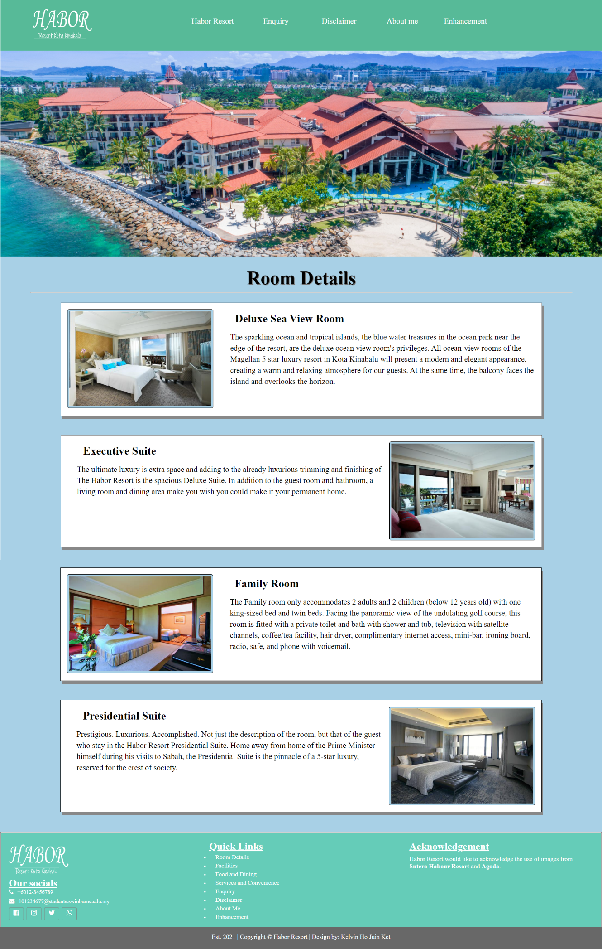

Actual User Interface: roombooking.html, facilities.html, food.html

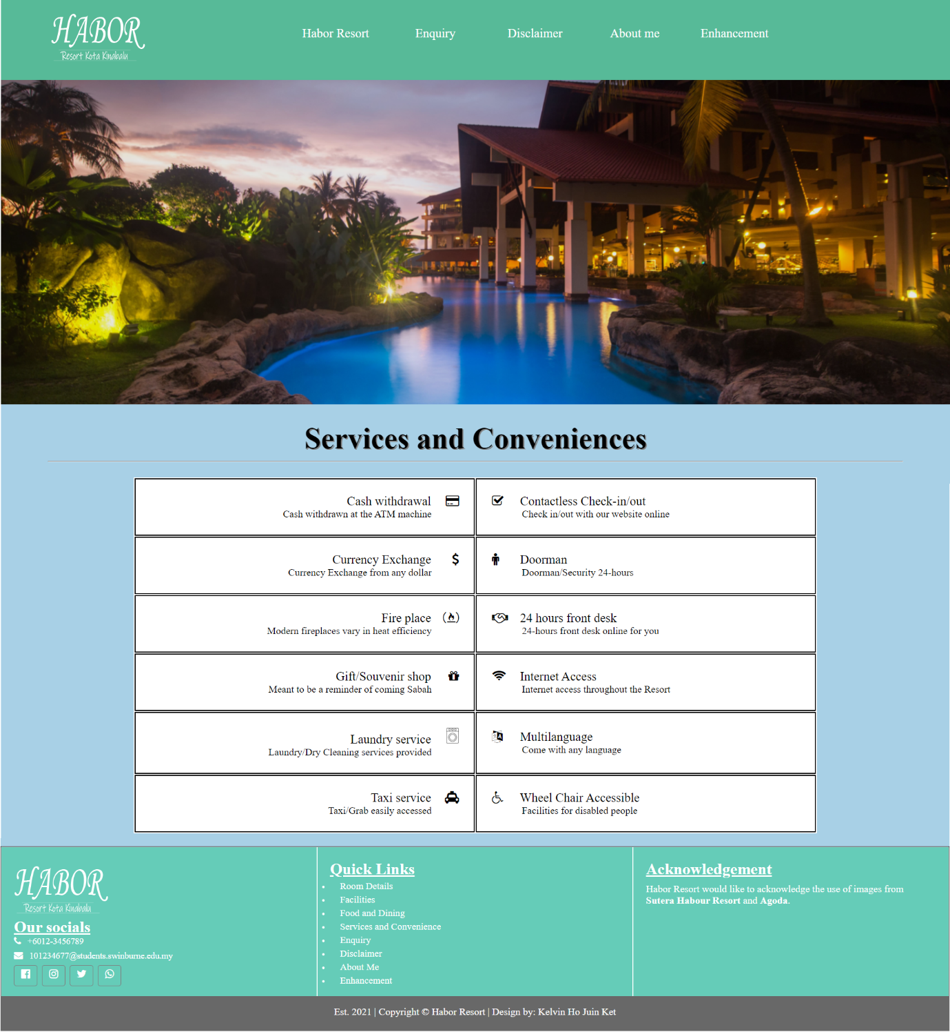

Actual User Interface: services.html

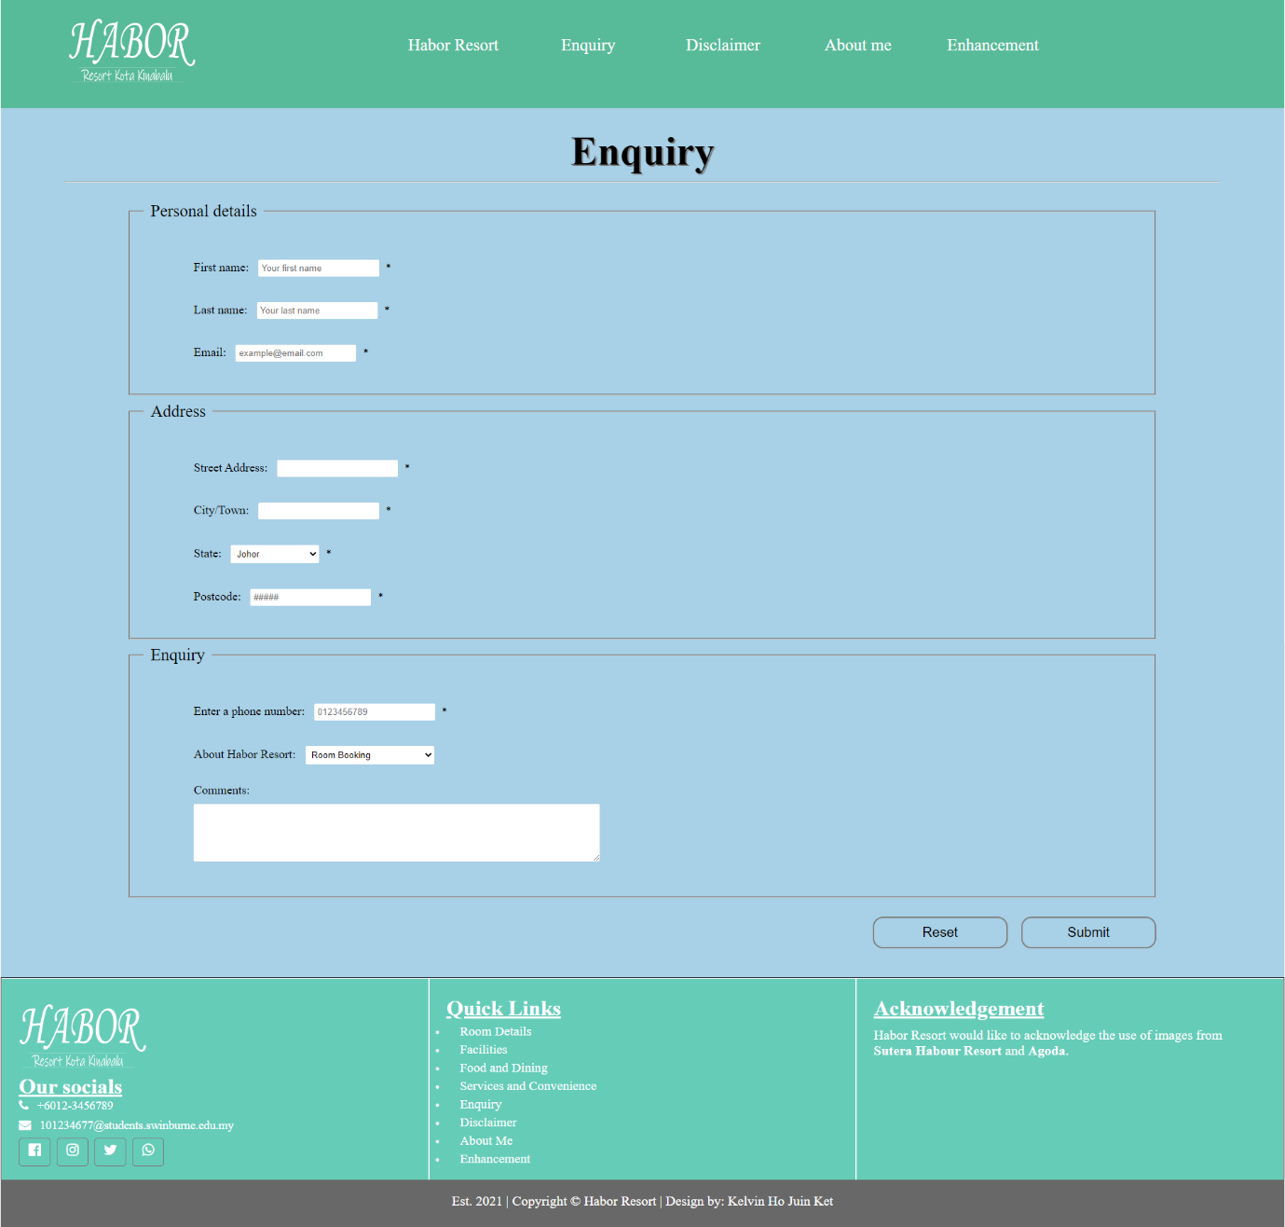

Actual User Interface: enquiry.html

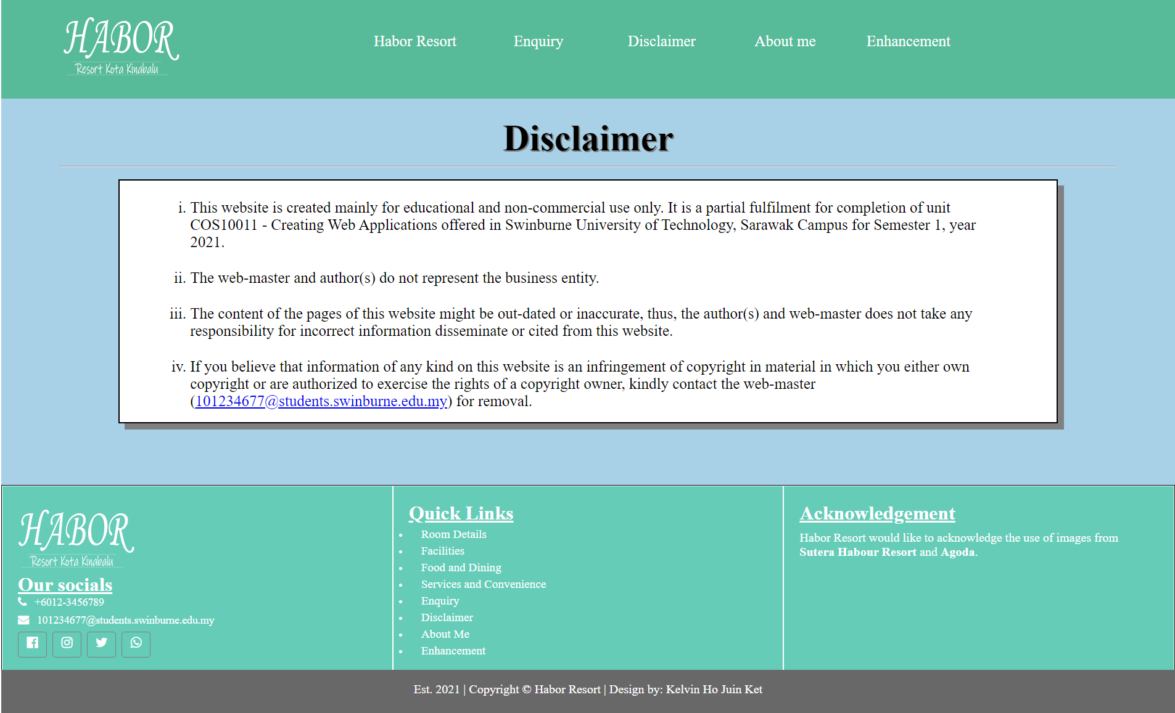

Actual User Interface: disclaimer.html

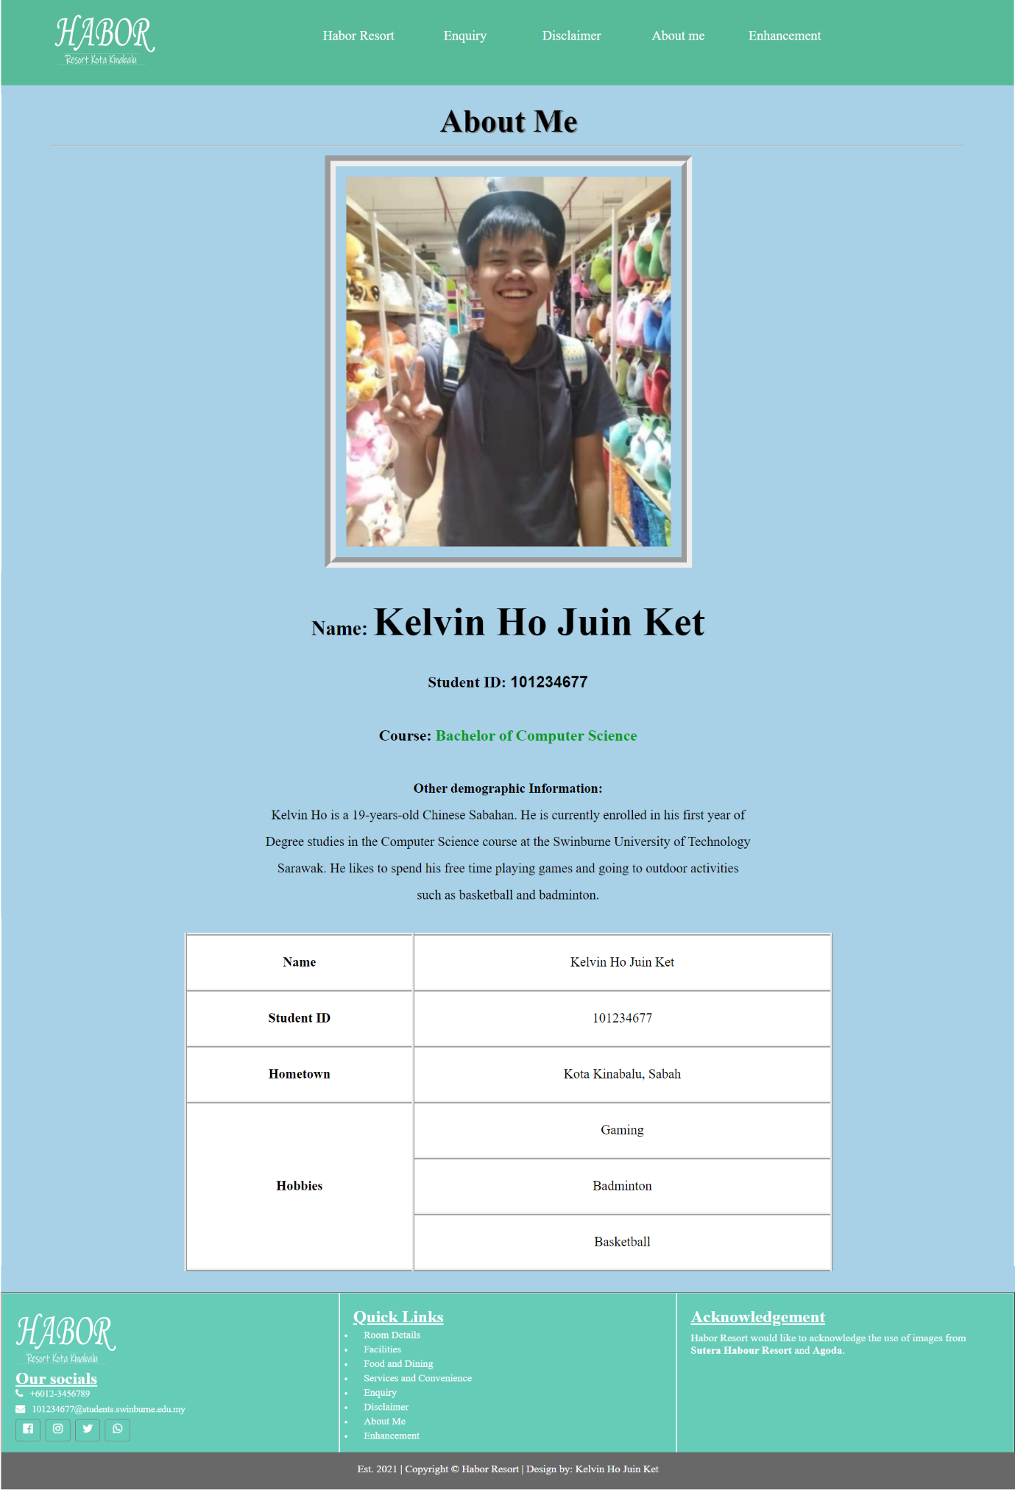

Actual User Interface: aboutme.html

### Enhancements (if any)

1. Image Slide Show (index.html)

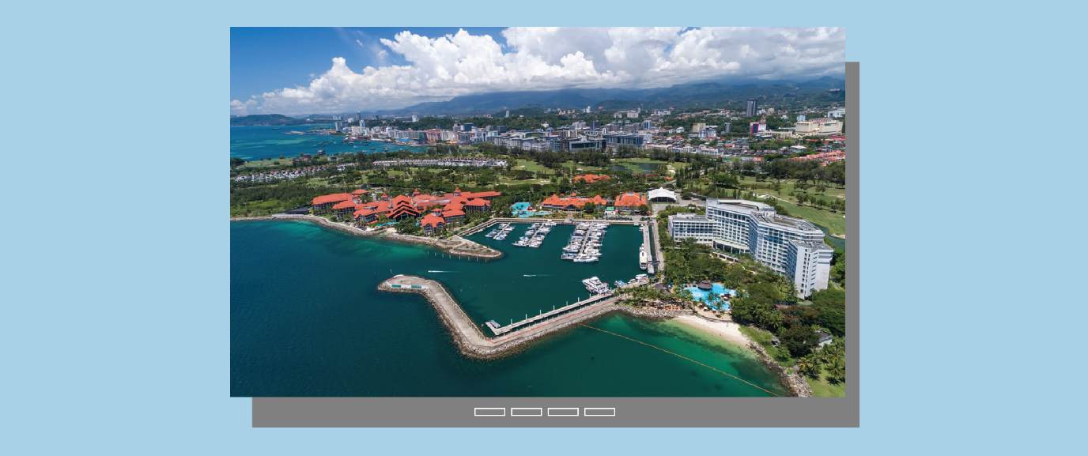The website utilizes HTML and CSS bullet input types in the use of an image slider. A user can hover each bullet(bar below) to view miniature version of that slide. A simple but effective way to preview upcoming slides.

1. Google Maps (index.html)

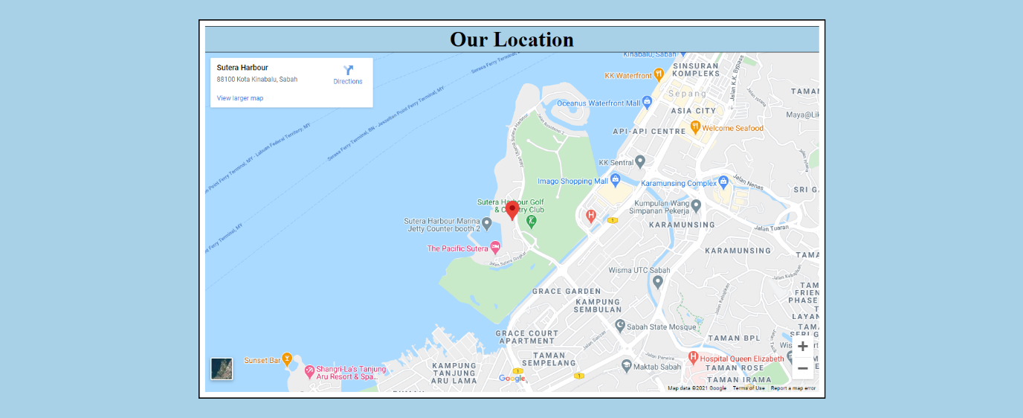The website goes one step further in customer service by adding Google Maps on our home page. Our location is located on a map that is framed inside a box using an iframe. Using Google Map, a user can select our shop's location and estimate the distance and reach time from their a site of their own choice.

# Assignment 2

## Description

1. Form Validator (enquiry.html)

The website uses JavaScript’s alert to validate information in enquiry form, some of them also includes pattern to be validated. I.e., first name and last name can only be alphabetic characters and limited to 25 characters, so the pattern will be “/^[a-zA-Z ]{1,25}$/”, then the function will validate the input with the pattern with “pattern.test”. If the input validated is false, the pop-up box(alert) will pop up when the user pressed the submit button.

1. Data Transfer Within Page (enquiry.html)

The website collect data from the value that user selected in the selection menu, then the data will be stored in sessionstorage, It will then written in the Subject textbox. This function will run whenever the user select an item in the selection menu as the website uses “onchange” in the selection menu.

1. Data Transfer Between Pages

(roombooking.html, facilities.html, food.html, services.html, enquiry.html)

The website adds a “Enquire now” button on every service which will send the data (name of service, index of select index) once the button is clicked, also, the webpage will be changed to enquiry.html with “window.location.replace("enquiry.html")”. After the webpage is changed, the name of service will be written in the Subject box and selection menu for the service will also be changed with the index sent from the button.

1. Product List (enquiry.html)

The website uses JavaScript to make array for the states and services then uses for loop to append it as a child of select and also option tag. With this function, the data in the array will be showed as selection menu when the webpage is loaded.

## End Product

1. 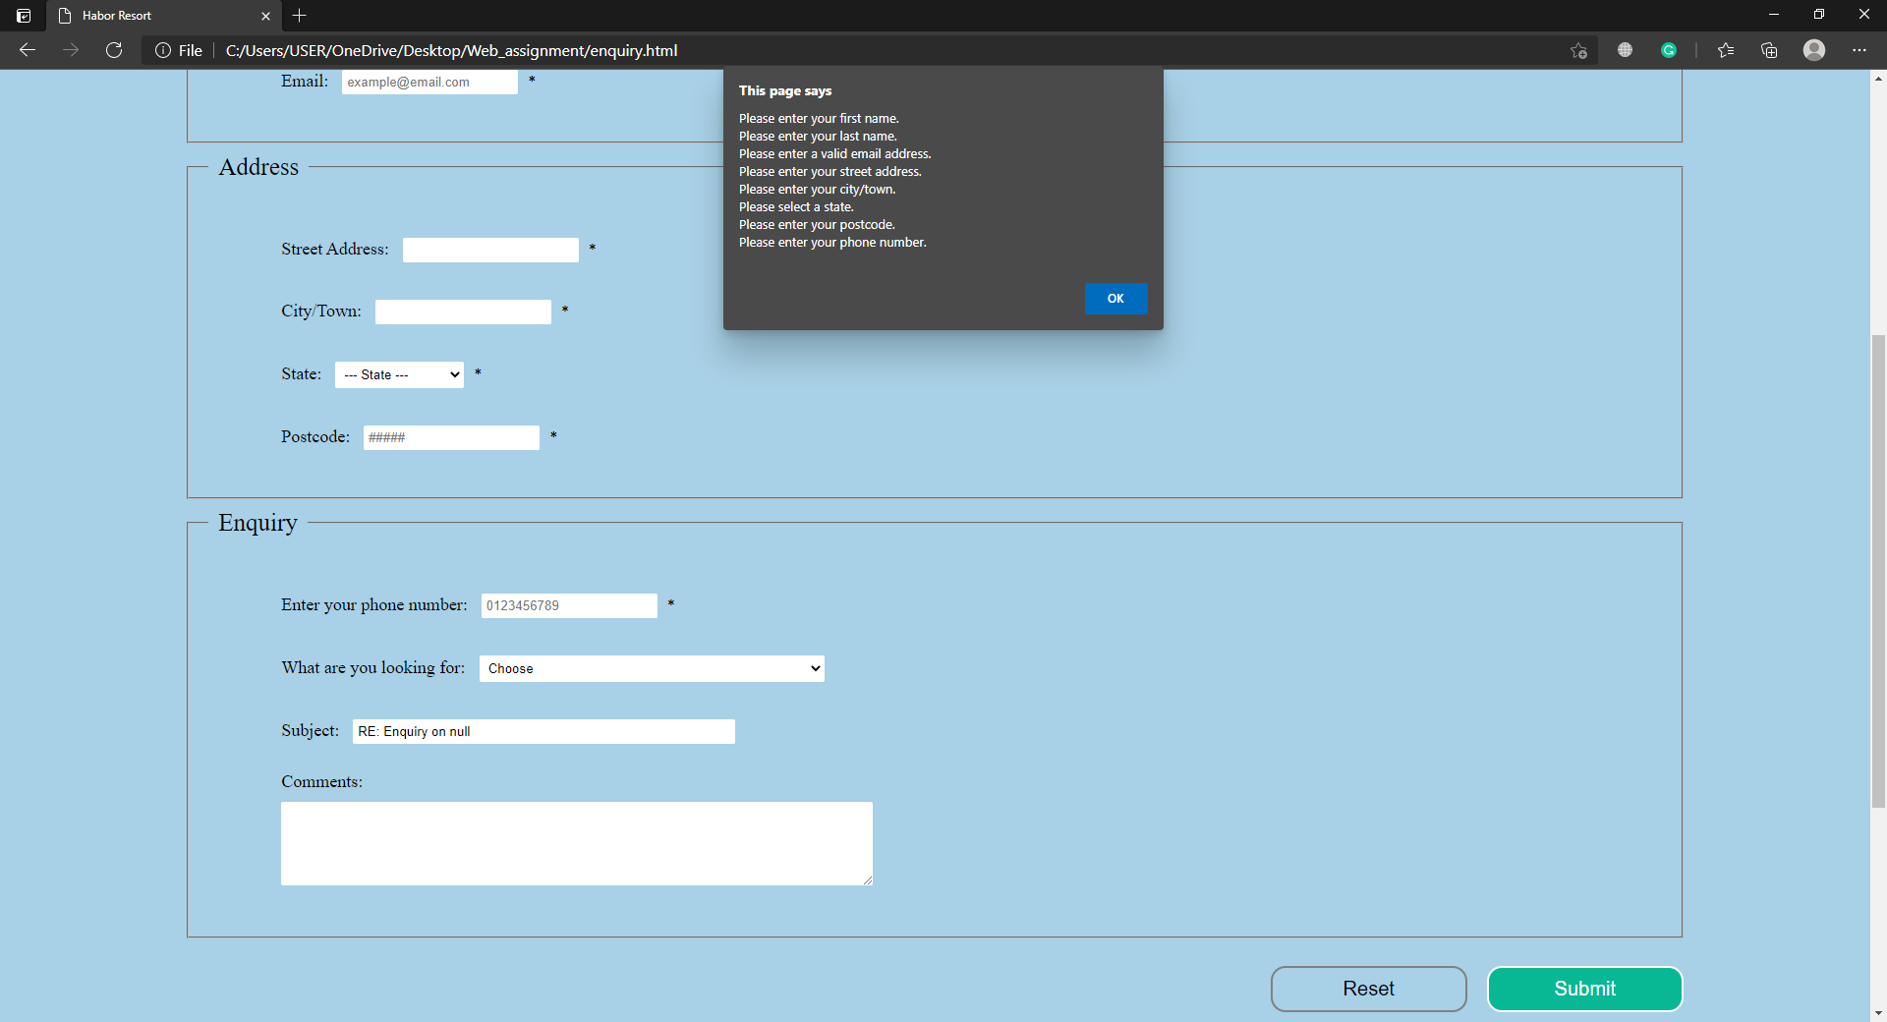Form validator

Js End Product: Pop-up alert when nothing was typed in enquiry form

1. 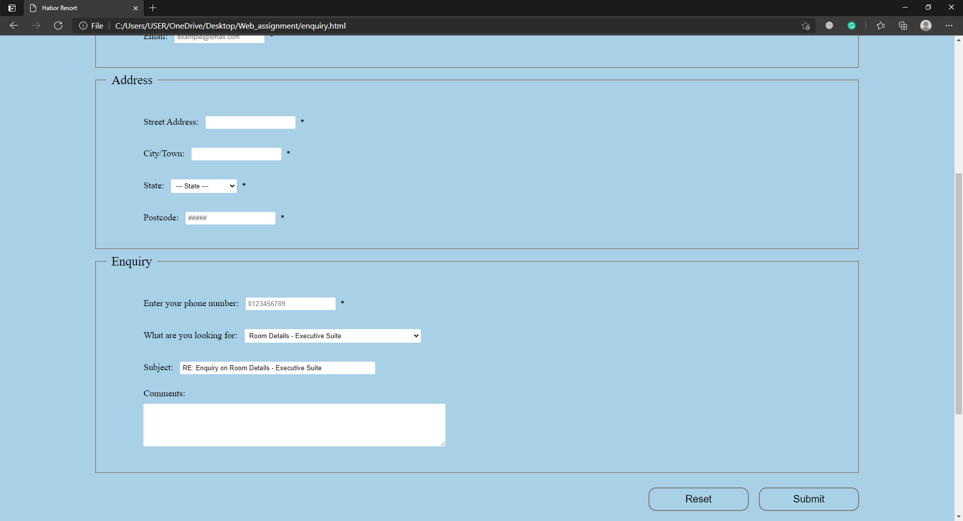Data Transfer Within Page

Js End Product: Subject will change whenever the selection menu is changed

1. Data Transfer Between Pages

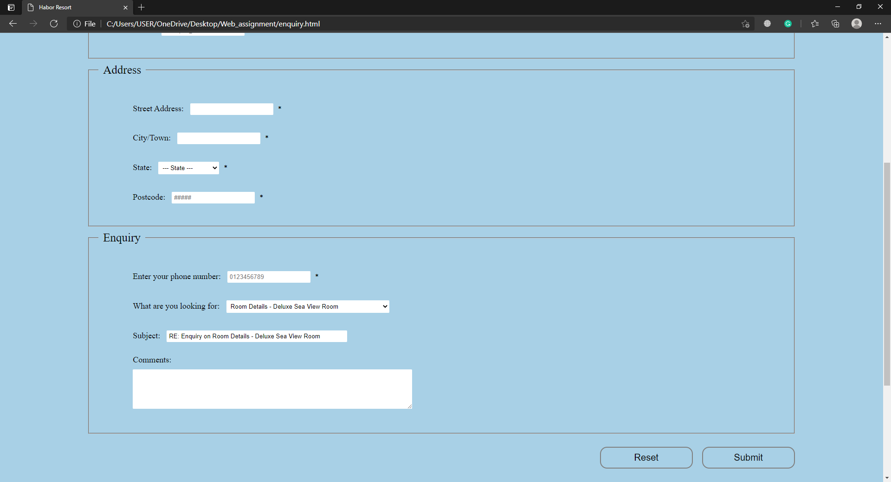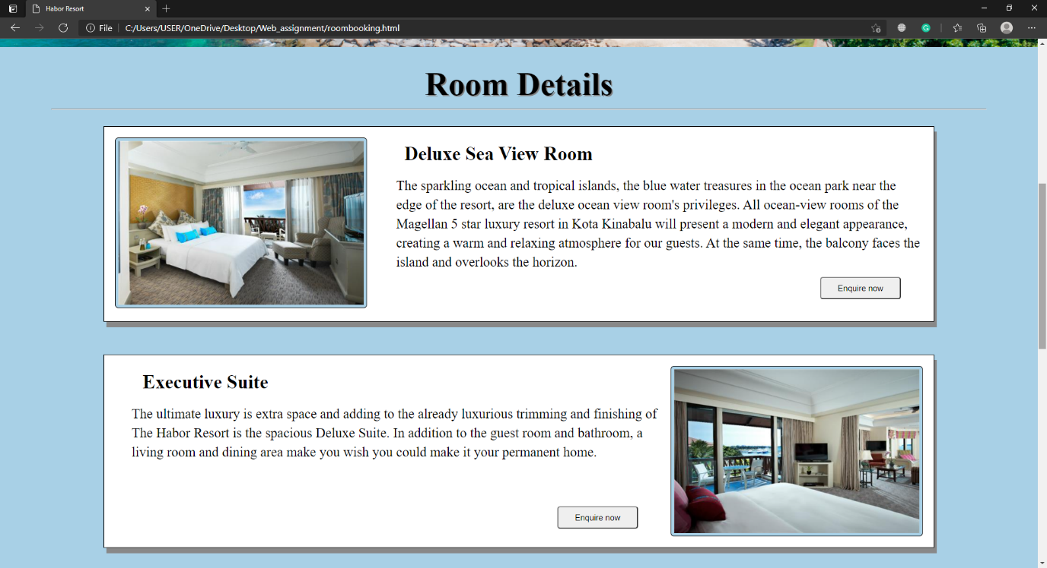

Js End Product: selection menu and Subject will be changed based on which “Enquire now” button was clicked

Js End Product: Enquiry now button added on every services

1. 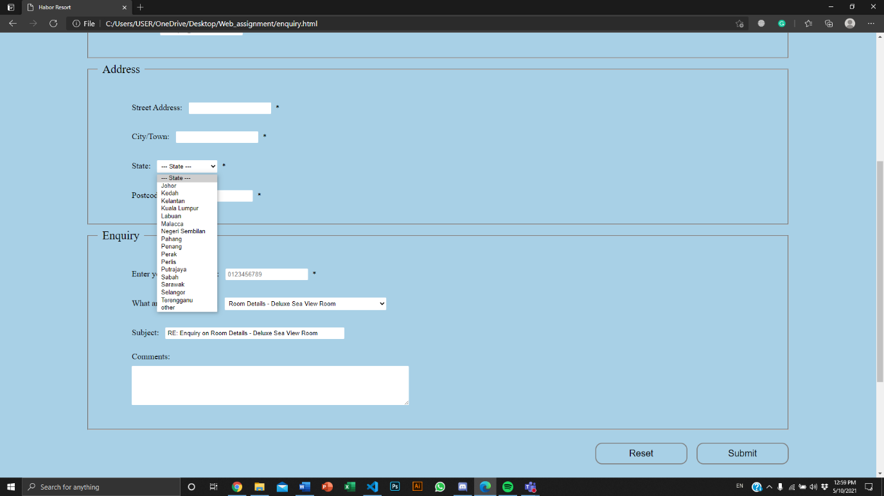Product List

Js End Product: for loop to append elements in array as a option

### 2.1 Enhancements

[Describe the enhancements if any]

1. JavaScript Image Slide Show

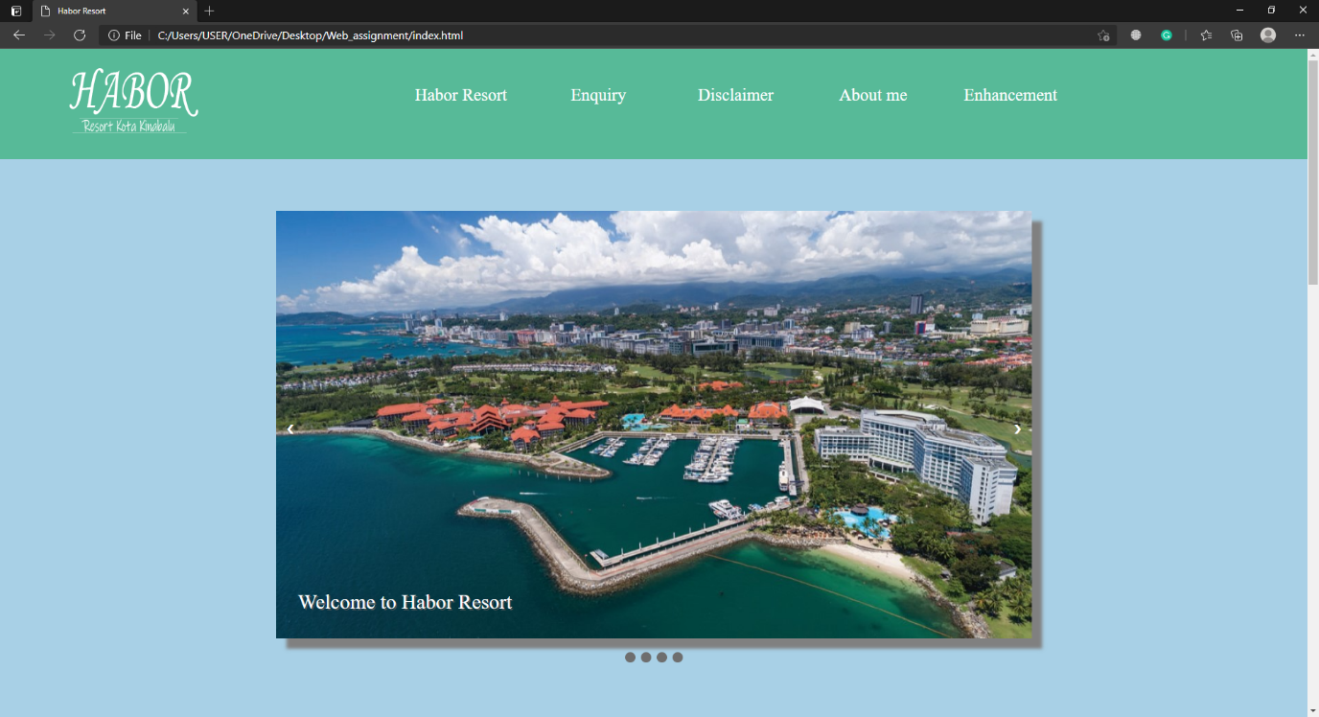The website utilizes JavaScript’s index in the use of an image slider. Also, the website used fade effect whenever next image is shown. A user can hover each bullet (dots below) to view miniature version of that slide. A simple but effective way to preview upcoming slides.

Js Enhancement 1: Image Slide Show

1. Enquiry Form Submission Confirmation

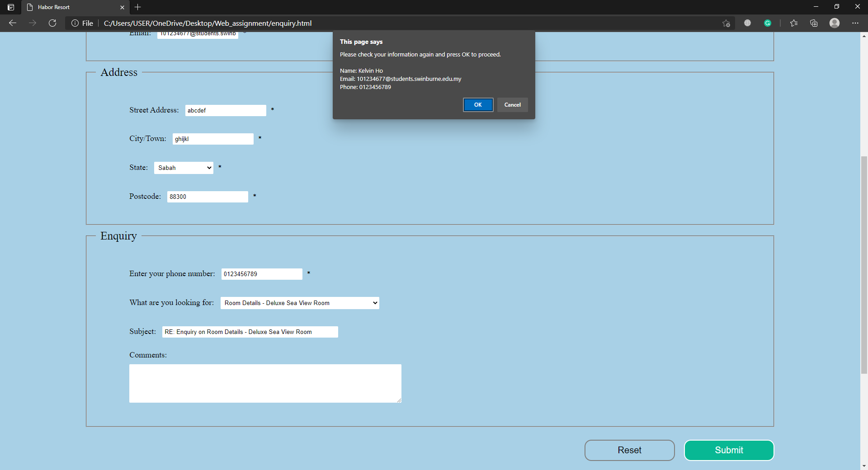The website utilizes JavaScript’s window.confirm in the use to make confirmation on information typed in enquiry form. The pop-up box shows the user's name, email and phone number for the user to do last checking.

Js Enhancement 2: window.function shows user’s name, email and phone number

# Assignment 3

In this Assignment 3, I have further enhanced the Web site I’ve developed in Assignment 1 and 2 using PHP and storing the server-side information in MySQL database. There are few essential specified requirements for this assignment.

## 1. Description

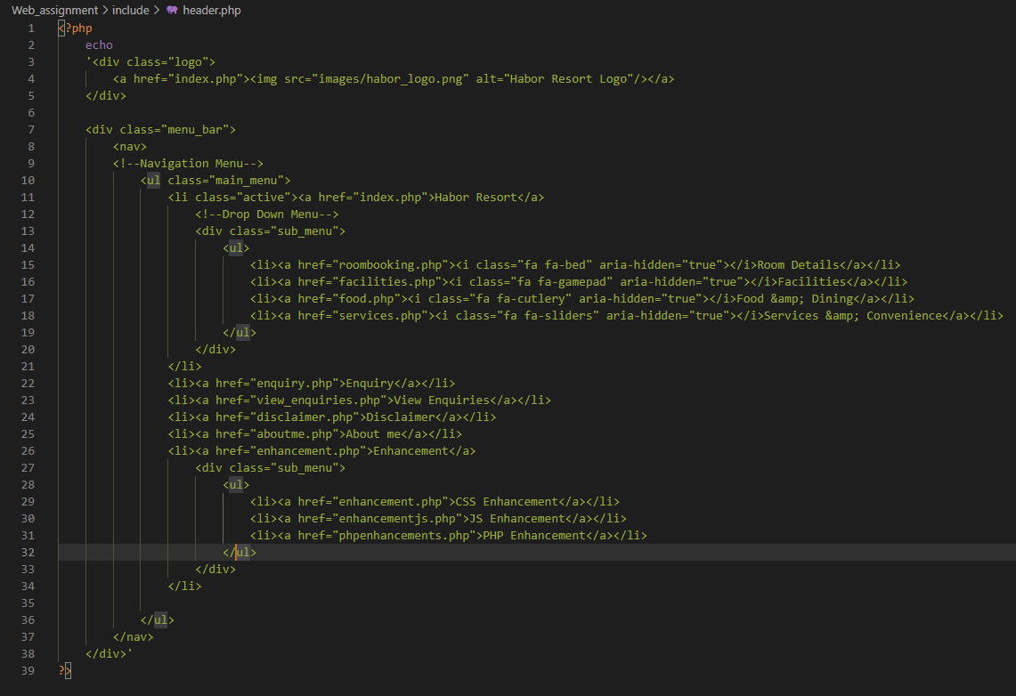 For the first requirement, which is use PHP to reuse common elements in the Web site. In my case, I’ve done this requirement by creating two new php files named header.php and footer.php, and the codes for my header and footer will be written in the respective file. Then I’ll just have to source my header.php and footer.php when I need it. As in this case, when I’ll have to change anything in the header or footer, I can just change it from my header.php or footer.php, which makes life easier.

header.php

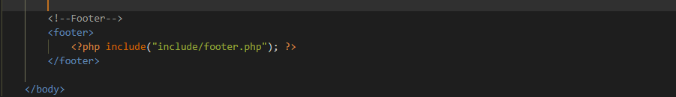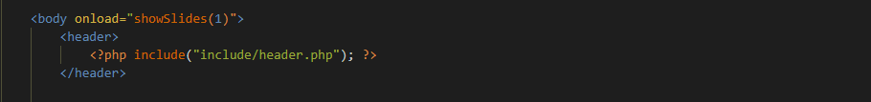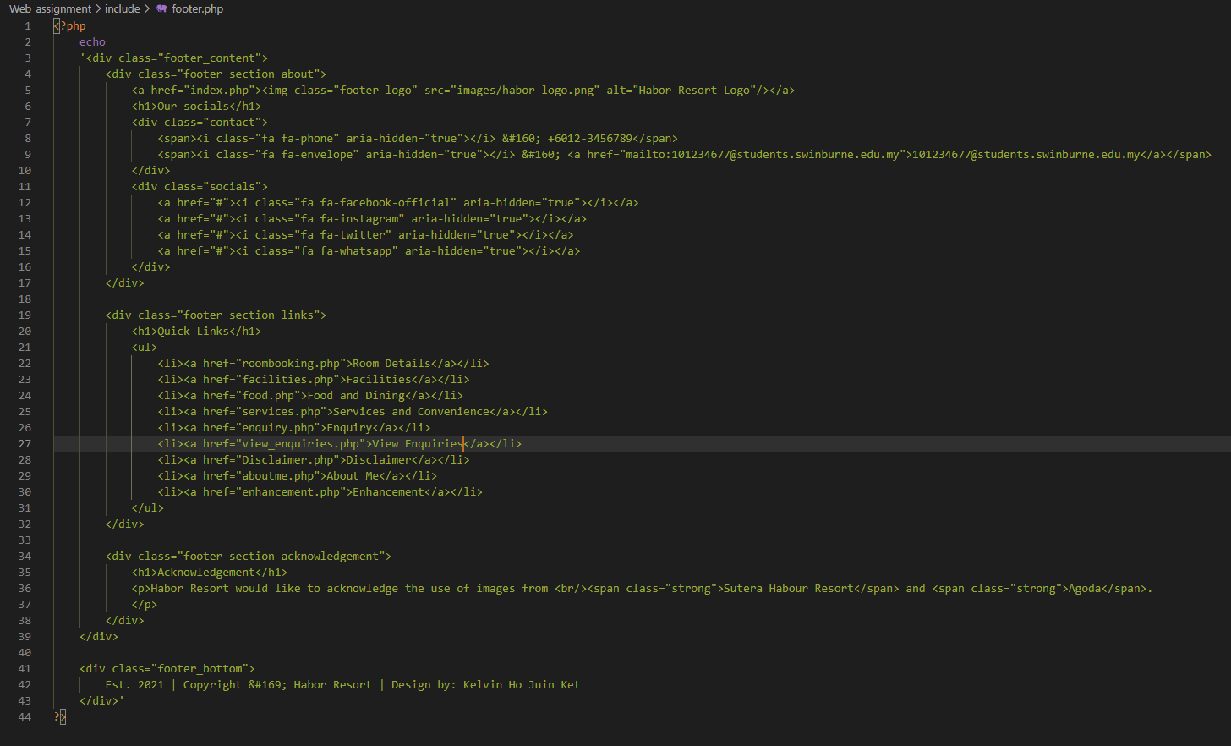

index.php (Sourcing footer.php from file ‘include’)

index.php (Sourcing header.php in file ‘include’)

footer.php

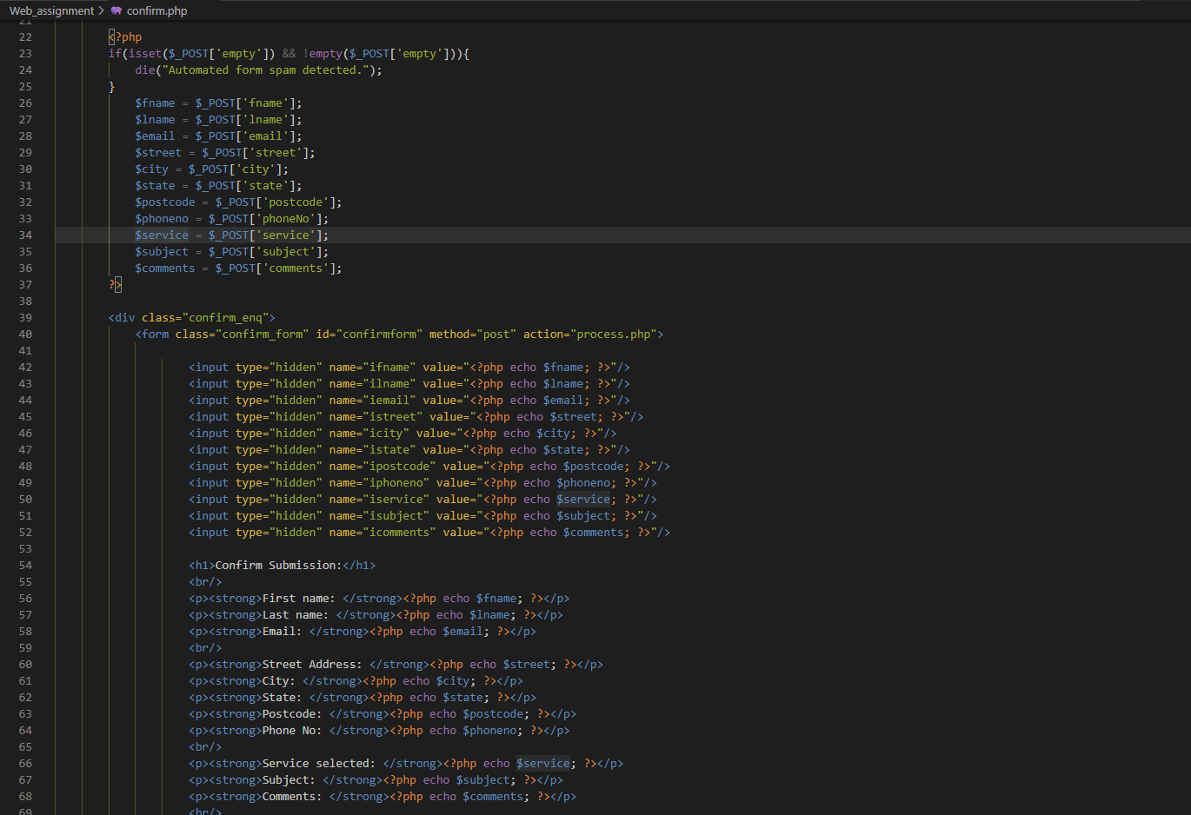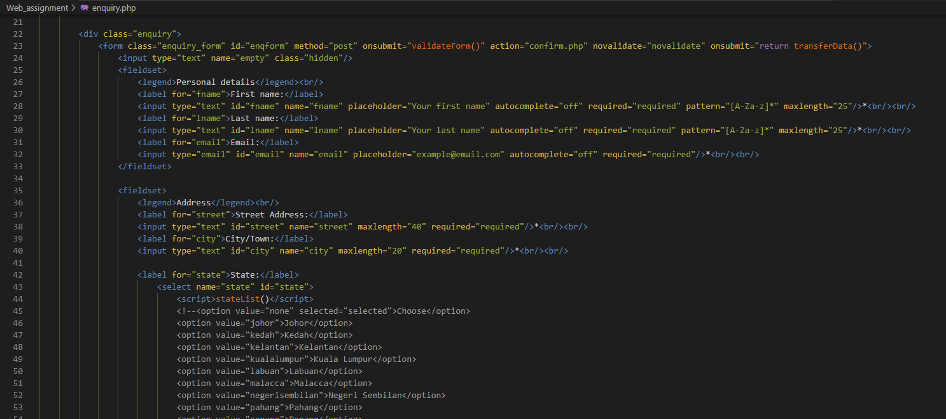Other than that, as I’m required to create a MySQL database and also create a table to store enquiry submissions in the database, I’ve created it in my process.php. In my process.php, I’ve create a database named ‘Habordb’, a table to store enquiry submissions named ‘EnquiryForm’, and I’ve coded my process.php to get attributes from confirm.php which confirm.php get the attributes from enquiry.php.

confirm.php (get attributes from enqruiry.php with $_POST and action=”process.php” to send it to process.php)

enquiry.php (action=”confirm.php” to send the attributes)

process.php (get attributes from confirm.php with $_POST, create database, table and insert values to table)

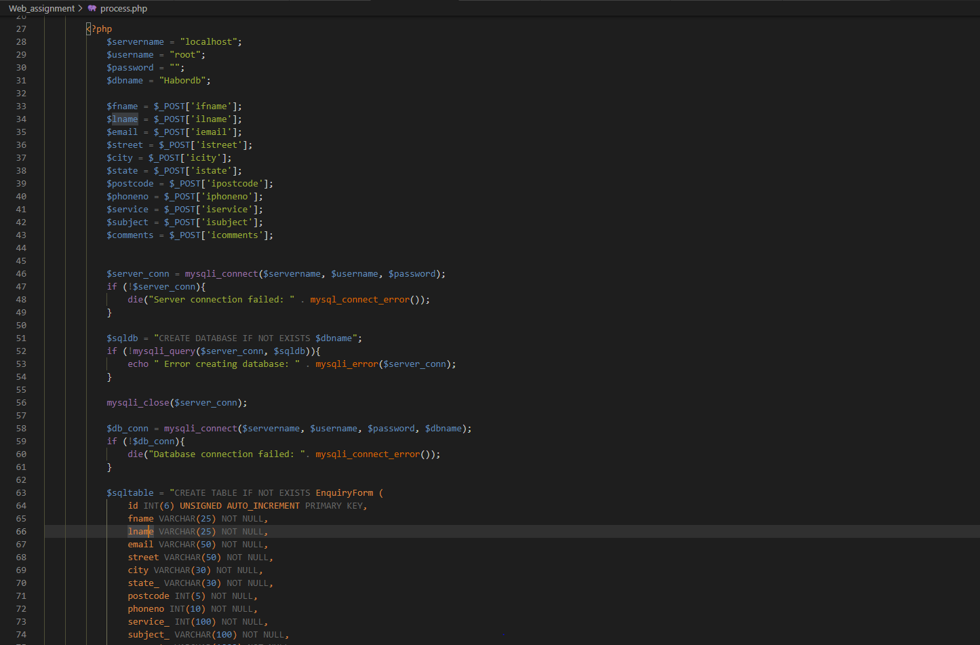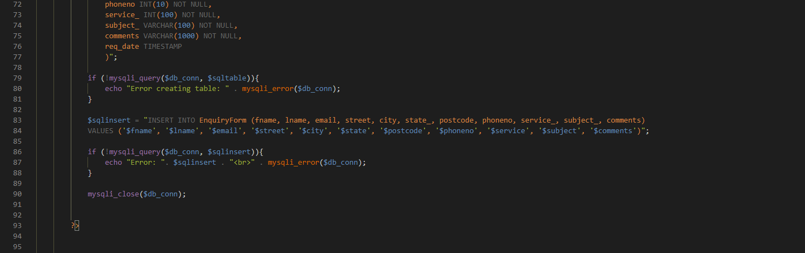

Lastly for the view enquiries, I am required to make a new page that shows all of the enquiry forms saved to the database’s table. I’ve created a new page named view_enquiries.php which will view all the enquiry forms submitted, and also I’ve done a enhancement on view enquiries which user can choose to view the enquiries with name ascended or descended.

view_enquiries.php (view the enquiries with sorting system)

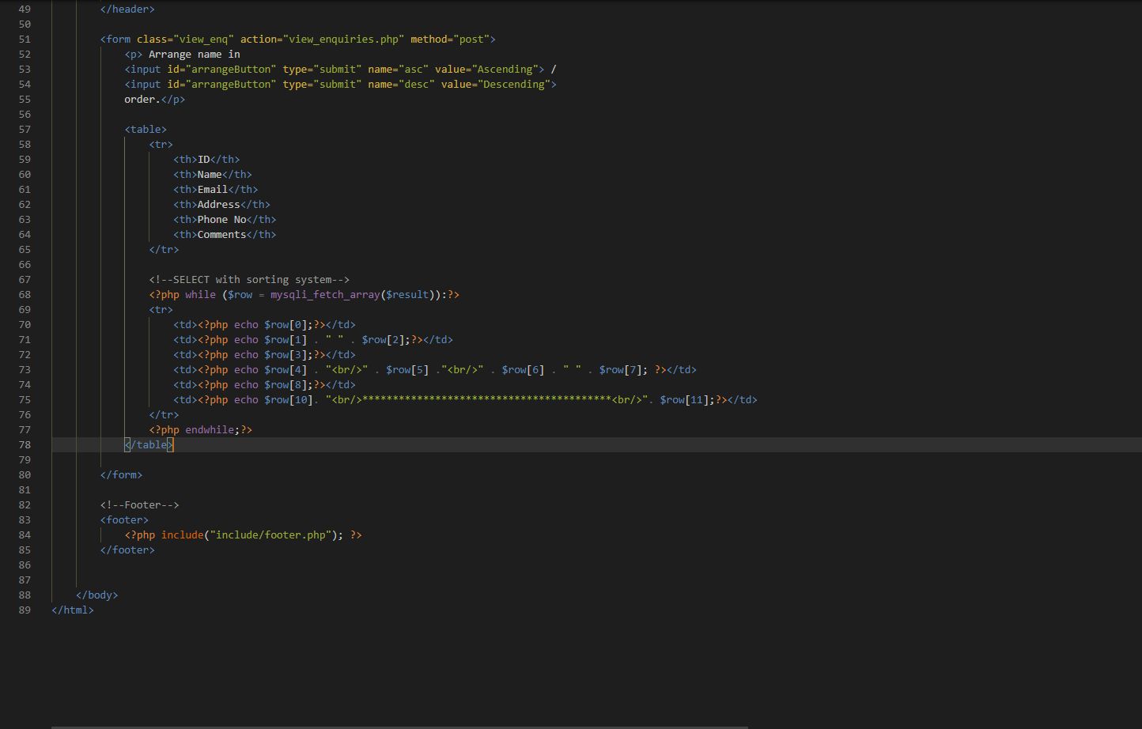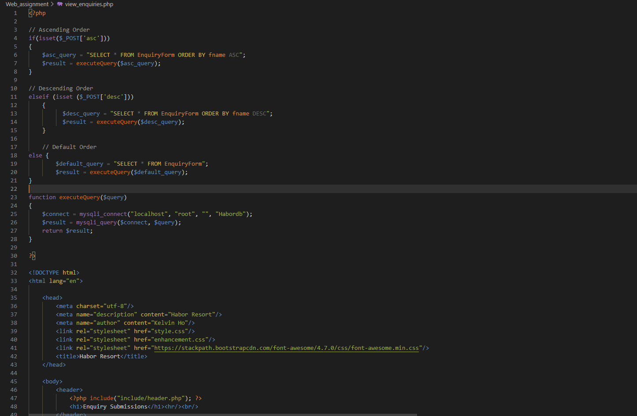

## 2. MySQL database structure/schema

**Server name**: “localhost”

**Username**: “root”

**Password**: “”

**Database**: “Habordb”

**Table**: “EnquiryForm”

|  |  |  |  |  |  |  |  |  |  |  |  |
| --- | --- | --- | --- | --- | --- | --- | --- | --- | --- | --- | --- |
| **userID** | **fname** | **lname** | **email** | **street** | **city** | **state_** | **postcode** | **phoneno** | **service_** | **subject__** | **comments** |
| 1 | a | b | abc@mail.com | 1, Friendly Garden | KK | Sabah | 88300 | 0123456789 | null | RE: Enquiry on Null | Hi |
| 2 | c | d | def@mail.com | 2, Taman Bukit Pulutan | KK | Sabah | 88300 | 0987654321 | null | RE: Enquiry on Null | Hello |
| 3 | e | f | ghi@mail.com | 3, Taman Ceria | KK | Sabah | 88300 | 0881234567 | null | RE: Enquiry on Null | This resort is good |

The table above is the table I’ve created in process.php with database named “Habordb” and table named “EnquiryForm”. This table is to store all of the information submitted by any user,

## 3. End Product

i. confirm.php

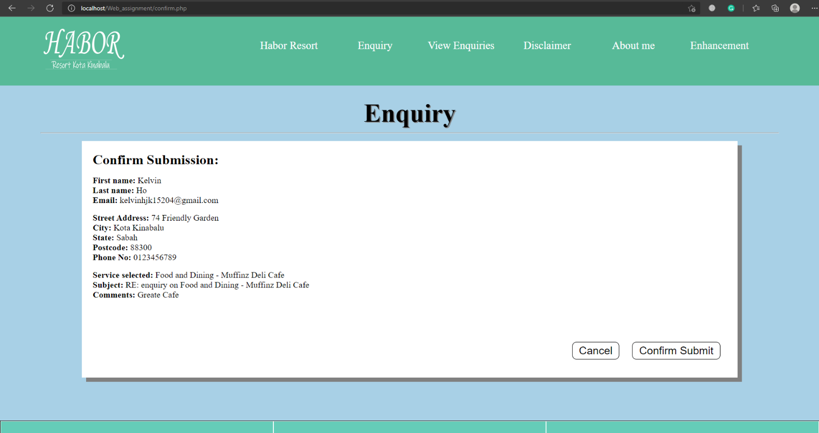 This is a confirmation page for the user to check their information filled in whether there’s any problem in it. If the user press on the cancel button, the webpage will change back to enquiry,php and the user can change their information and submit again. If the user clicked on the confirm submit button, the information will then send to process.php and save to the database’s enquiry table.

ii. process.php

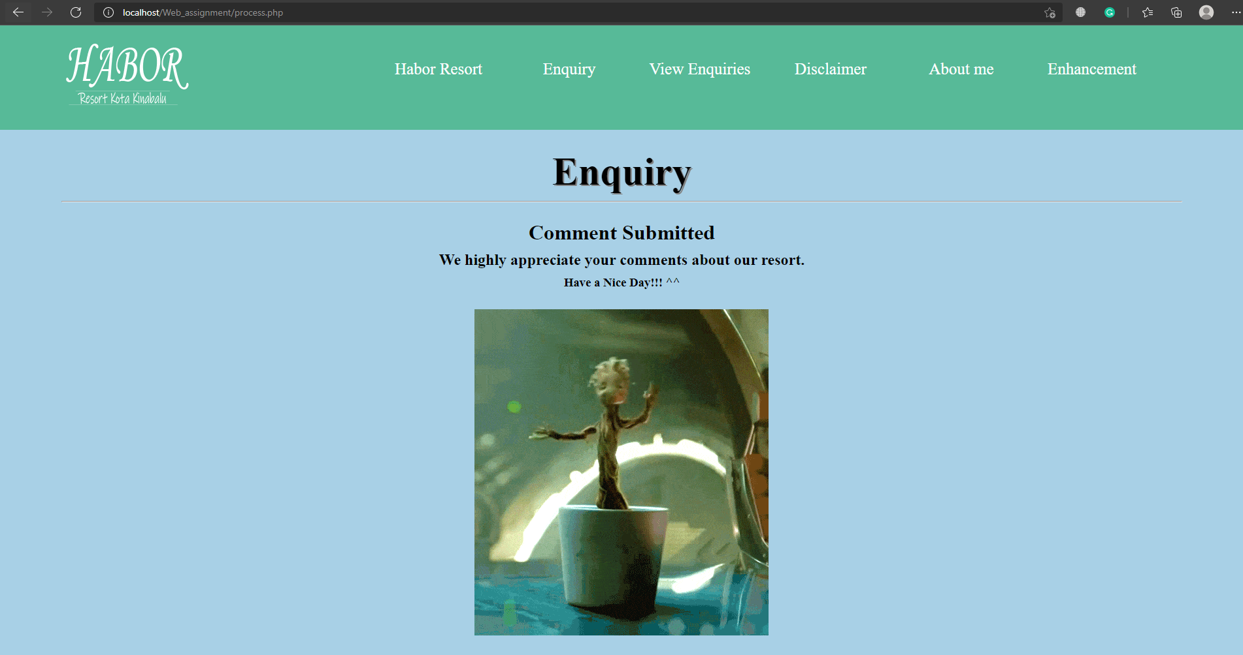 This page will process the information sent from the confirm.php and save it to the database’s enquiry table in the background. The page will not show the information again instead will thanks the user for the comments.

ii. view_enquiries.php

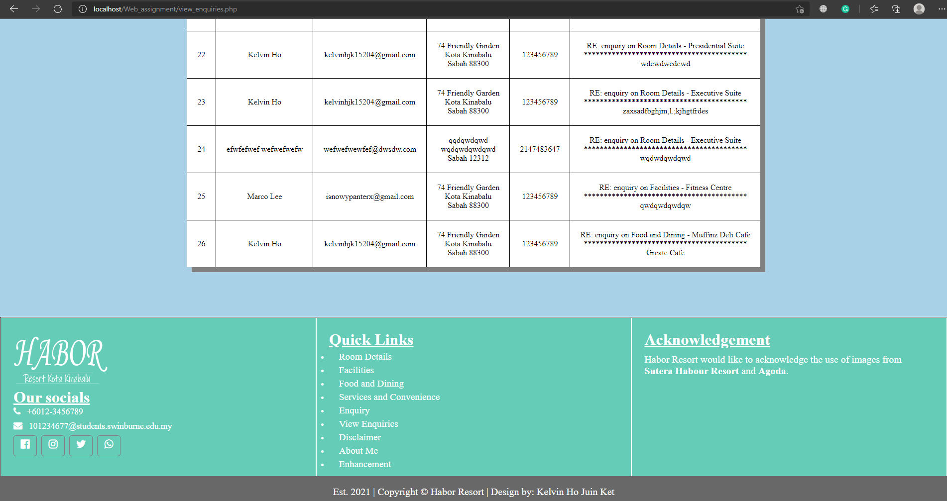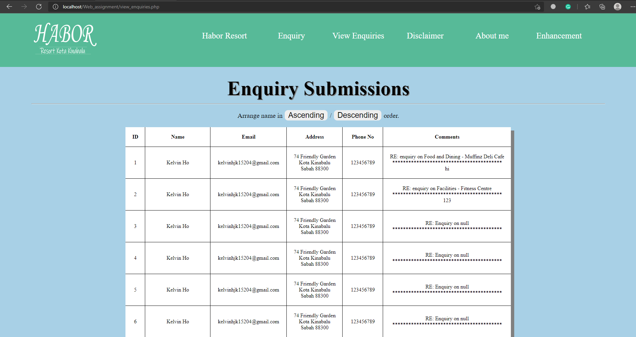 This page will retrieve data from the database’s enquiry table and display it on the webpage.

### 3.1 Enhancements (if any)

i. Sorting system

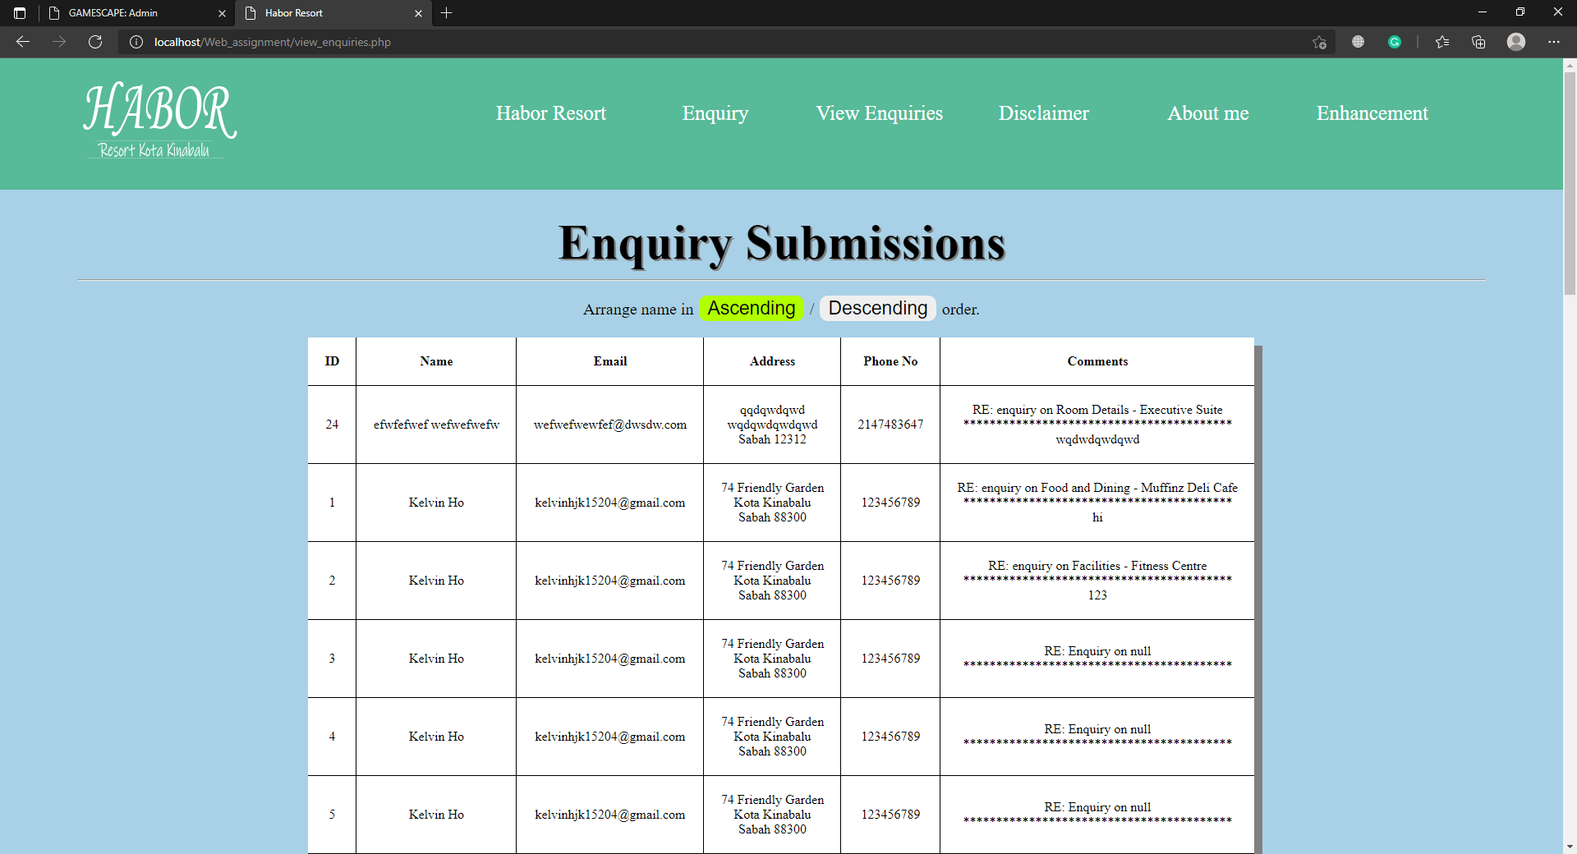The website utilizes PHP and MySQL database to do sorting for element export from the database. A user can select to sort the name showed in ascending order or descending order when viewing the enquiries submissions.

Sorting names in Ascending order

Default view

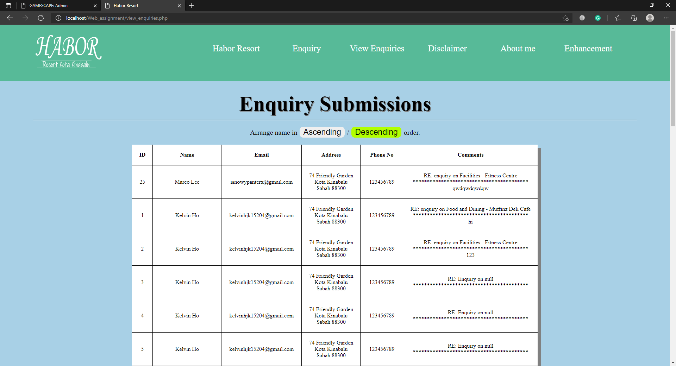

Sorting names in Descending order

**End of Report**